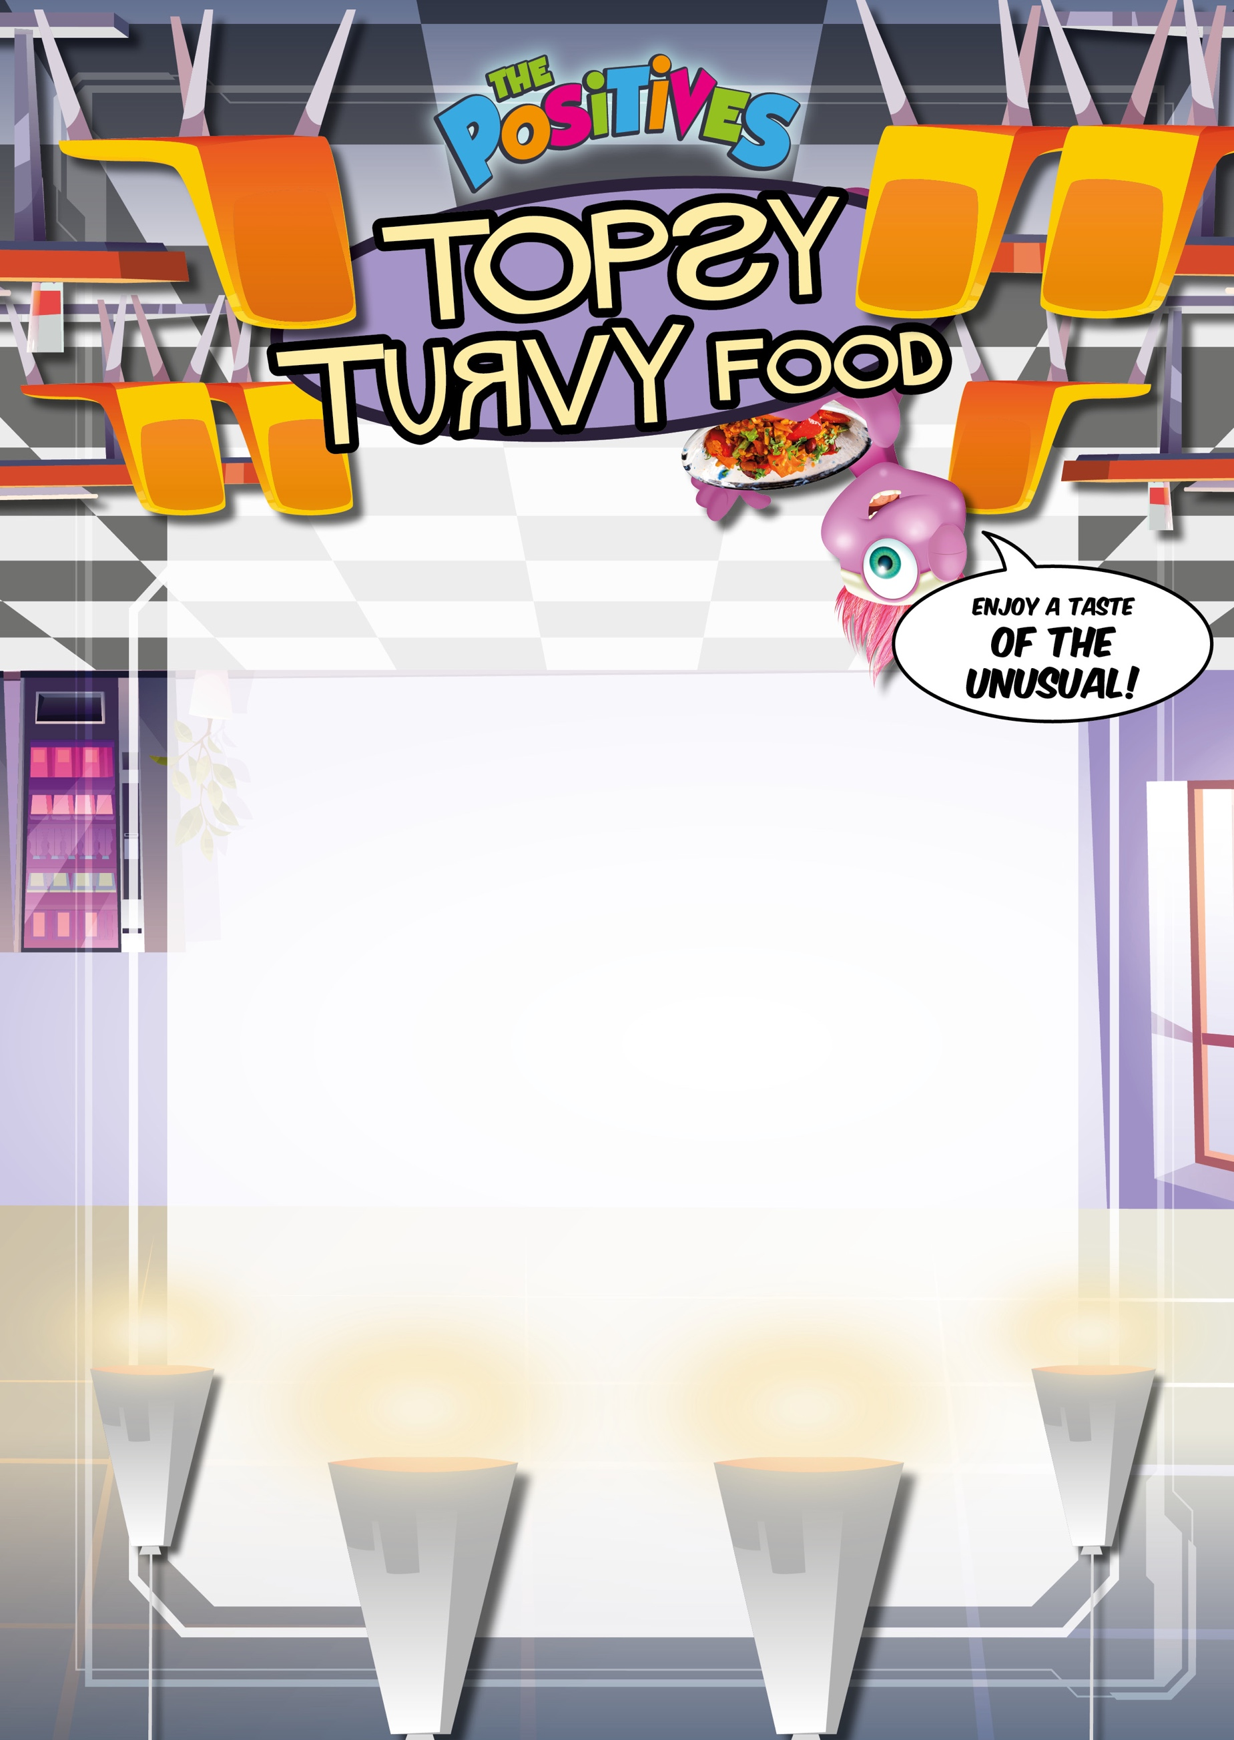
Mains:

Upside Down Cheese and Tomato Pizza
gluten, milk
Upside Down Beef Burger
gluten, sulphur dioxide & sulphites, sesame
Sides:

Positives Chips

Sweetcorn

Baked Beans

Dessert:

Pineapple Upside Down Cake with Custard
gluten, eggs, milk

