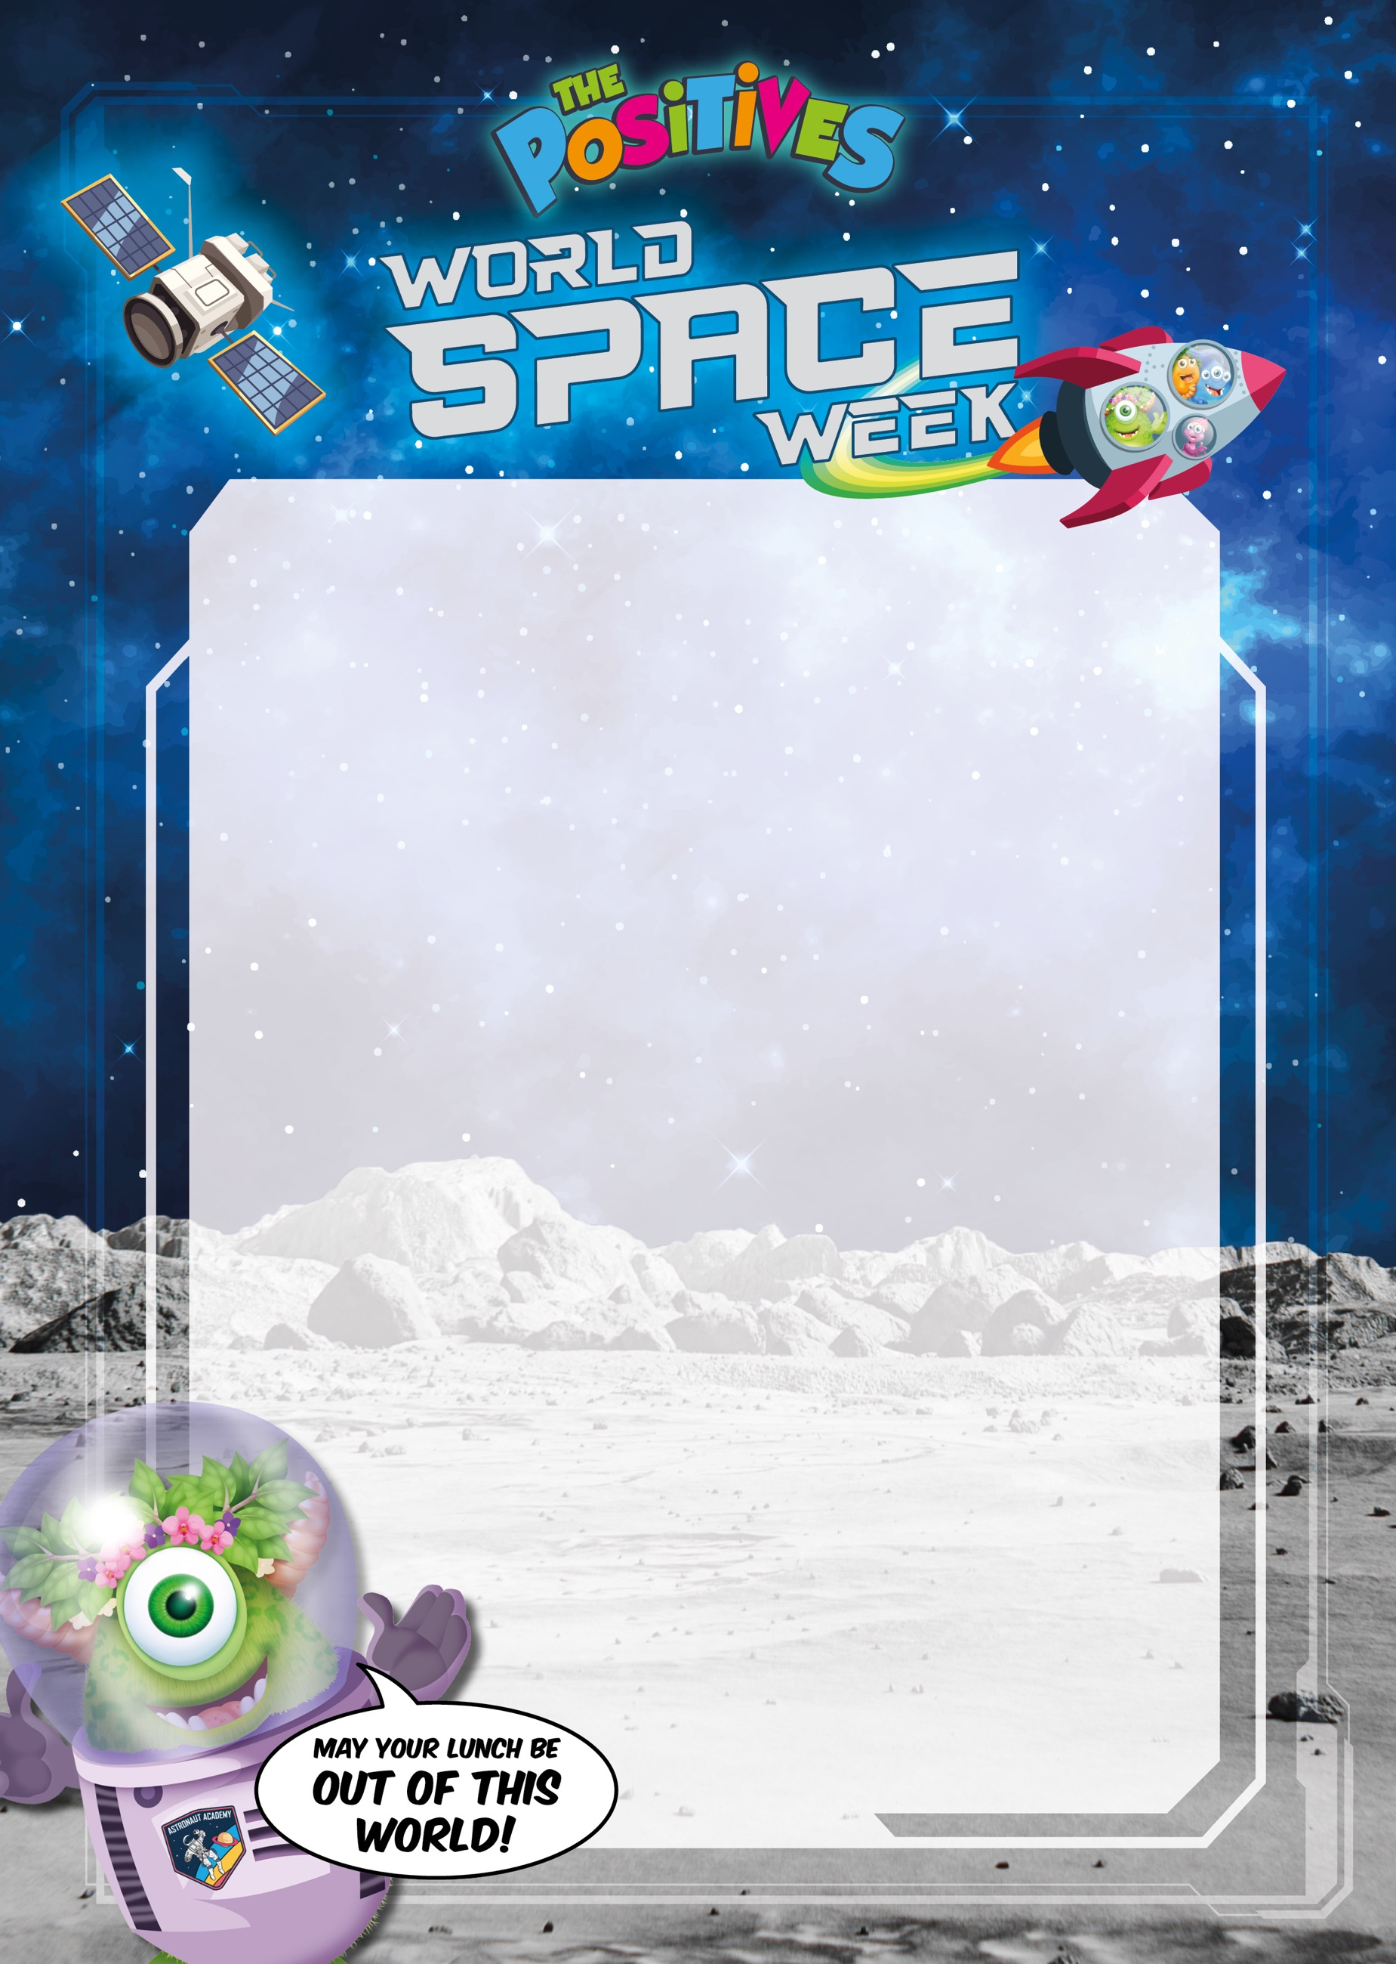
Mains:

Meteorite Meatball Pasta
gluten

Meteorite Vegan Meatball Pasta
gluten, soya

Sides:

Cosmic Garlic Bread
gluten

Dessert:

Moon Biscuits
gluten, milk

