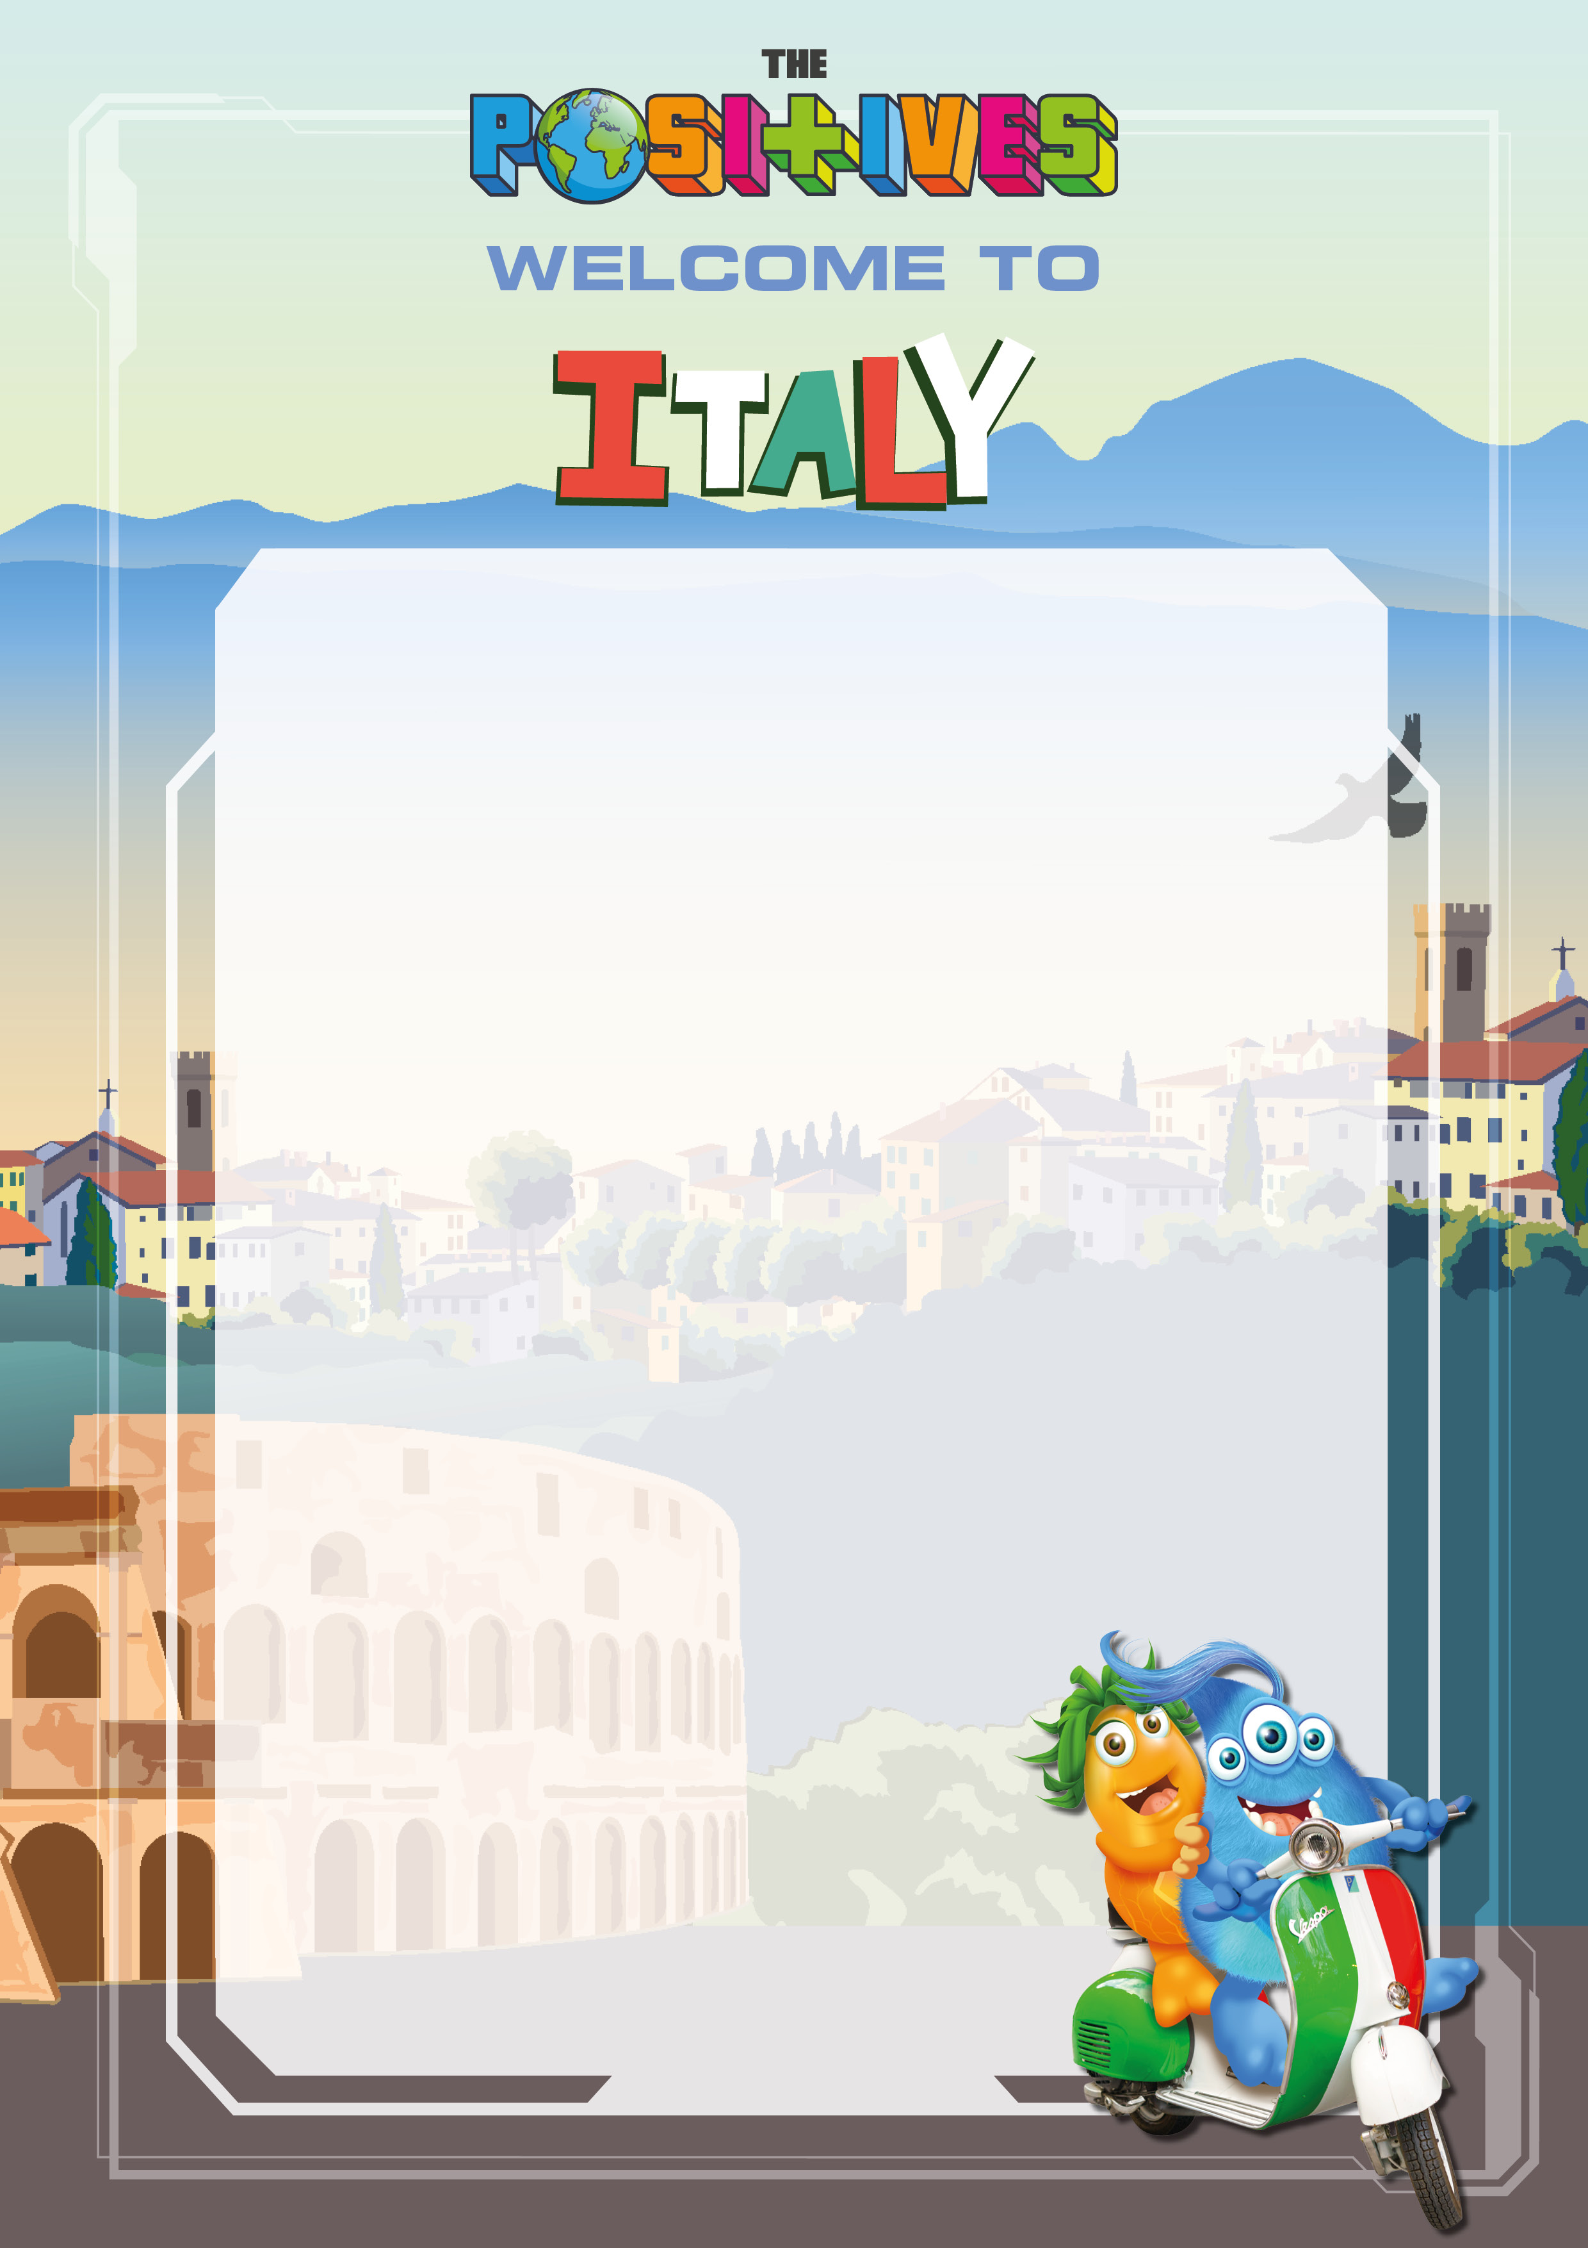

Margherita pizza

Pepperoni pizza

Spaghetti bolognaise

Fries & garlic bread slices
Help yourself to the salad trolley

Choice of Sandwiches
~

Italian Gelato Sundae
Vanilla Ice cream with chocolate
brownie pieces, toffee sauce and
topped with white chocolate buttons

